Exercise 1: Write a program that prompts the user for two integers, and then performs the following

operations using those integers: addition, subtraction, multiplication, division, modulus, and floor

division. Print the results of each operation to the console.

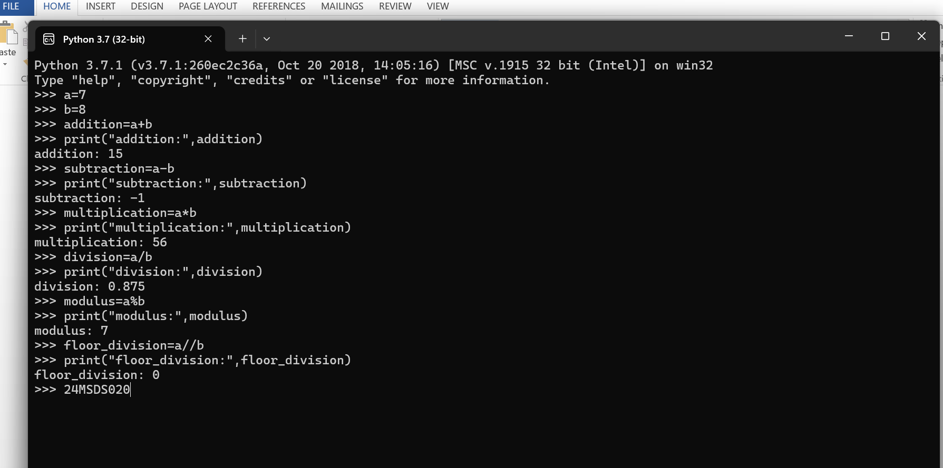

Exercise 2: Write a program that prompts the user for a string, and then performs the following

operations using that string: concatenation, repetition, and indexing. Print the results of each operation

to the console.

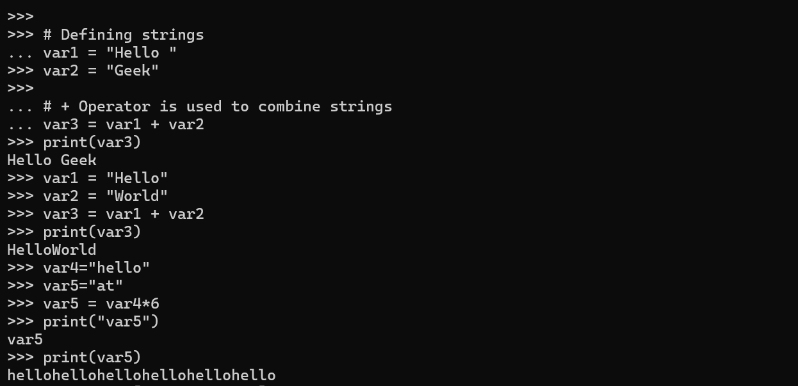

Exercise 3: Write a program that prompts the user for a list of integers, and then performs the following

operations using that list: appending, inserting, and removing elements. Print the results of each

operation to the console.

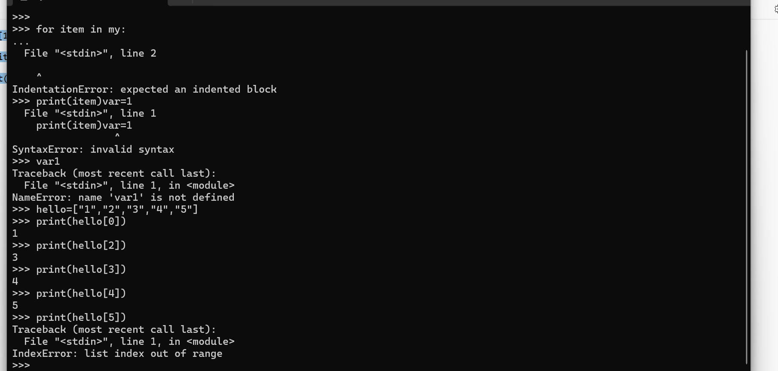

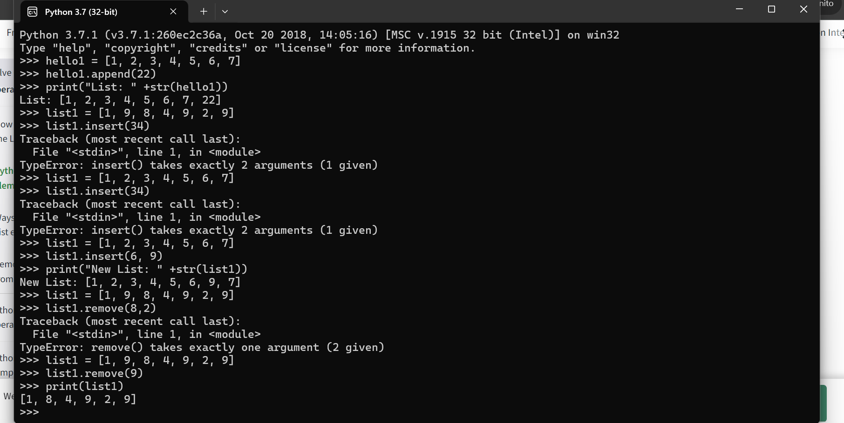

Exercise 4: Write a program that prompts the user for a number, and then performs the following

mathematical operations: square root, power, trigonometric and logarithmic functions. Print the results

of each operation to the console.

